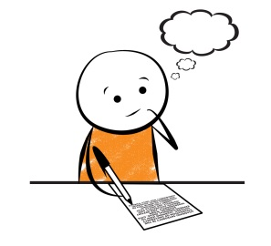**What makes a great paragraph?**

*List your own ideas here:*

|  |
| --- |
|  |



*List the criteria we brainstormed as a class here:*

|  |
| --- |
|  |