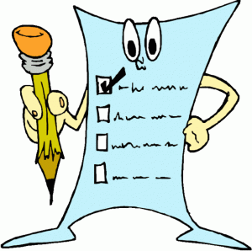

**Paragraph Checklist**

**Before handing in your paragraph, please go through this checklist and see if you have met each of these criteria. Take your time and use this checklist to help you improve your writing.**

Introduction

Hook (catch the reader's attention; tie into your topic sentence)

Topic Sentence (title, author, main idea)

Thesis (your argument -- answer the prompt)

Point # 1

Assertion

Citation (with paragraph or line number)

Explanation

Point 2

Assertion

Citation (paragraph or line number)

Explanation

Point 3

Assertion

Citation (with paragraph or line number)

Explanation

Conclusion

A final statement that sums up your points and refers back to the prompt.

Other

I **have used** *transition word*s to connect together my ideas.

I have **not used** *personal pronouns* (I, me, we)

I have **not used** *contractions* (can't, won't, etc.)

**SCORING GUIDE FOR STAND-ALONE TEXT**

**This is a first-draft response and should be assessed as such. The use of paragraph structure is assessed holistically with reference to the clarity of expression and organization.**

**6 --** The six response is **superior** and may draw upon any number of factors, such as depth of discussion,

effectiveness of argument, or level of insight. It exhibits an effective writing style and a sophisticated use

of language. Despite its clarity and precision, the response need not be error-free.

**5 --**The five response is **proficient** and reflects a strong grasp of the topic and the text. The references to the passage may be explicit or implicit and convincingly support a thesis. The writing is well organized and demonstrates a strong command of the conventions of language. Errors may be present, but are not

distracting.

**4 --**The four response is **competent**. The assertions tend to be simplistic; there are no significant errors in

understanding. References are present and appropriate, but may be limited to only part of the text. The writing is organized and straightforward. Conventions of language are usually followed, but some errors are evident.

**3 --**The three response is **barely adequate**. Understanding of the topic and/or the text may be partially flawed. Support may consist of long references to the text which are not clearly connected to a central idea or may be meagre or repetitive. The response may show some sense of purpose, but errors may be distracting.

**2 --** The two response is **inadequate**. While there is an attempt to address the topic, understanding of the text or the task may be seriously flawed. Errors are recurring, distracting, and often impede meaning.

**1 --** The one response is **unacceptable**. Although the response attempts to address the question, it is too brief or there is a complete lack of control in the writing.

**0 --** The zero response reflects a complete misunderstanding of the text and/or the task, is off-topic, or is a

restatement of the question.

**NR --** A blank paper with no response given.

|  |  |  |  |
| --- | --- | --- | --- |
| **Final Thoughts and Suggestions** | | | |
| **2 things the writer did well** | 1.  2. | | |
| **2 things to work on next time** | 1.  2. | | |
| **Peer Marker Grade** |  | **Teacher Grade** |  |