C:\Users\Bronwen\AppData\Local\Microsoft\Windows\Temporary Internet Files\Content.IE5\W7RNC8PV\MC900379067[1].wmf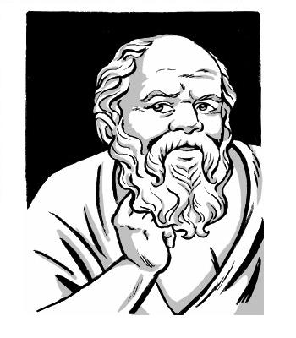

**Socratic Circles**

**The Goal of a Socratic Circle is:**

-For students to engage in a conversation (**a dialogue**) to collectively seek a deeper understanding of complex ideas.

**Dialogue is:**

1. Collaborative

2. Listening to find agreement and meaning

3. Enlarges and possibly changes point of view

4. Complicates positions and issues

5. Dialogue is NOT a debate.

**In a successful discussion, students will:**

* take turns (don’t interrupt or dominate the conversation)
* listen actively (nod, confirm, respond)
* make eye contact
* include everyone
* be tolerant and respect the opinion of others
* build on another’s point and explain ideas thoroughly
* make direct reference to points made by other students
* disagree constructively
* stay on-task
* support your views giving evidence from the novel/story/play/poem/article
* speak loudly and clearly
* complete the pre-discussion tasks fully

**Evaluation**

-You will be evaluated based on *four* different components:

-Did you complete the pre-discussion task fully?

-Did you meet the above discussion criteria?

-Did you complete your peer assessment?

-Did you complete your written reflection?

C:\Users\Bronwen\AppData\Local\Microsoft\Windows\Temporary Internet Files\Content.IE5\93SNSLWP\MC900441902[1].wmf