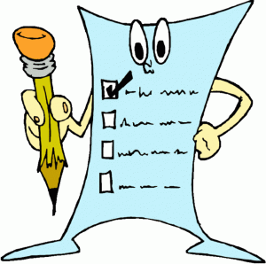**Research Essay Peer Edit Checklist**

***Plan/Outline & Thesis Statement***

Yes No Plan clearly states at least 3

points that will be discussed.

Yes No A clear thesis is used.

Yes No Evidence in the essay supports

the thesis.

***Hook/Attention Grabber***

Yes No Is interesting.

Yes No Relates to the topic.

Yes No Makes you want to read

more.

***Conclusion***

Yes No Restates the main idea in a new

way.

Yes No Is interesting.

Yes No Does not repeat the introduction.

***Body Paragraphs***

Yes No Each body paragraph starts

with a topic sentence.

Yes No Each body paragraph ends with

a concluding sentence

Yes No Use evidence to support points.

***Quotes***

Yes No Each quote is integrated into

the text.

Yes No Reporting phrases are used.

Yes No Each quote is properly cited

in M.L.A style.

***M.L.A Format***

Yes No Paper is formatted following

M.L.A criteria.

Yes No Works Cited is properly

formatted following M.L.A

criteria.

Yes No At least three sources are

included in works cited.

***Writing Style***

Yes No Transition words are used

Yes No No personal pronouns

(I, me, we)

Yes No No contractions

(can’t, won’t)

Yes No No simple errors

(there, their, they’re)

***Punctuation/Word Choice***

Yes No Periods and commas are used

appropriately

Yes No No run-on sentences

Yes No Periods are placed after MLA

citation

Yes No Specific and accurate words

are used.