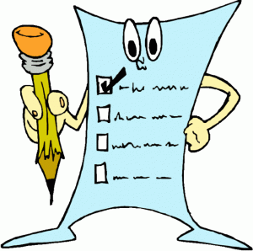

**Paragraph Checklist**

**Before handing in your paragraph, please go through this checklist and see if you have met each of these criteria. Take your time and use this checklist to help you improve your writing.**

Introduction

Hook (catch the reader's attention; tie into your topic sentence; introduce topic)

Topic Sentence (introduces your main idea)

Thesis (your argument -- answer the prompt) (can also be part of topic sentence)

Point # 1

Assertion

Citation or Proof (with paragraph or line number)

Explanation

Point 2

Assertion

Citation or Proof (with paragraph or line number)

Explanation

Point 3

Assertion

Citation or Proof (with paragraph or line number)

Explanation

Conclusion

A final statement that sums up your points and refers back to the prompt.

Other

I **have used** *transition word*s to connect together my ideas.

I have **not used** *personal pronouns* (I, me, we)

I have **not used** *contractions* (can't, won't, etc.)

**Paragraph Scoring Criteria**

**6**

**•** A relevant position/thesis, as directed by the command term, is clearly stated.

• Superior recall of factual content; organized in a thoughtful and effective manner.

• Position is supported with thoroughly developed details and insightful conclusions are drawn.

• Expression is clear and fluent with few flaws in communication.

**5**

• A relevant position/thesis, as directed by the command term, is clearly stated.

• Proficient recall of factual content; organized in a thoughtful and effective manner.

• Position is supported with well-developed details and effective conclusions are drawn.

• Expression is generally fluent with few flaws in communication.

**4**

• A relevant position/thesis, as directed by the command term, is adequate.

• Competent recall of factual content; generally organized in a clear manner.

• Position is supported with sufficient details and adequate conclusions are drawn.

• Expression is sufficiently fluent; errors do not impede meaning.

**3**

• A relevant position/thesis, as directed by the command term, is adequate.

• Minimal recall of factual content; organization is attempted.

• Position is supported with some detail and conclusions are weak.

• Expression is limited; errors may distract and impede meaning.

**2**

• A position/thesis is insufficient.

• Limited recall of factual content; lacks organization.

• Absence of supporting details, little or no relevant conclusion.

• Expression is awkward; errors interfere with meaning.

**1**

• A position/thesis is absent.

• Deficient recall of factual content; lacks organization.

• Absence of supporting detail.

• Expression is full of errors making understanding difficult.

|  |  |  |  |
| --- | --- | --- | --- |
| **Final Thoughts and Suggestions** | | | |
| **2 things the writer did well** | 1.  2. | | |
| **2 things to work on next time** | 1.  2. | | |
| **Peer Marker Grade** |  | **Teacher Grade** |  |