**End**

**Beginning**

Evidence

Trait # 4

Trait # 1

Evidence

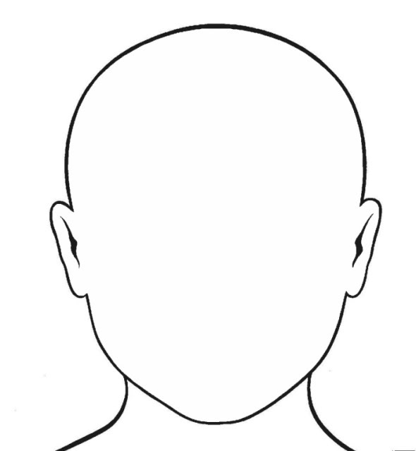

Evidence

Trait # 6

Evidence

Trait # 5

Evidence

Trait # 2

Evidence

Trait # 3