Character Analysis
Guided Viewing Activity and The Big Bang Theory
Character | Clip 1 – What is he/she like in this clip? | Clip 2 – What is he/she like in this clip? | Clip 3 – What is he/she like in this clip? | The Verdict? Is this character dynamic or static, round or flat, or stereotypical? Remember, a character can be more than one!
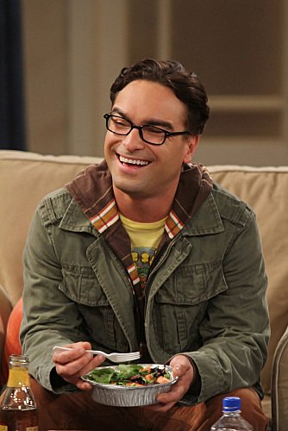
Leonard
Penny

Character | Clip 1 – What is he/she like in this clip? | Clip 2 – What is he/she like in this clip? | Clip 3 – What is he/she like in this clip? | The Verdict? Is this character dynamic or static, round or flat, or stereotypical? Remember, a character can be more than one!
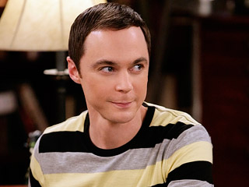
Sheldon
Howaaaard!!!!

Mrs. Wolowitz

